Compiled by Green Potatoes

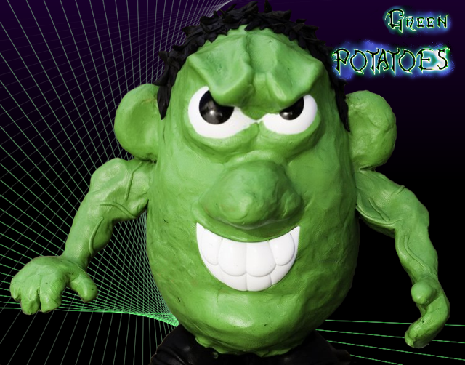

# Legends of War

Overview - High Concept

## High Concept Statement:

## Legends of War is a top down two player hero “tug”. The player battles through to destroy the opponent’s portal by commanding an army of minions and his/her hero.

## Comparable products:

* + League of Legends(Dominion, Battles)

|  |
| --- |
| https://lh6.googleusercontent.com/o6guQE1cR6JVc17wsCZFQlVFJQqAmgGxEM6g3M1Y3NXC9wo0a5KaS00ts7Yo3RfJCToMW4OyhB8lA2NEsF76d7GHYgYQFhkff-ljU88SOX0E4jVZIZCBT-PuTOygdE-Nphfno2PW |
| Controllable Hero and the minions waves are similar in both games. |

* + Starcraft

|  |
| --- |
| https://lh5.googleusercontent.com/QDvl1bVgCf3qtiNr0MLRnH7d5pxmgF9O5plD2jDUsHV4kWs6lbAjX0NnV6uDciW23fLUihJOOaN8xYc7NnoUCUuO1ngcdESmNtMMNEbdtrhk21YublqVmjwVErXA8KsYwK2P1kWO |
| The economy system and the micro-managing of the army are comparable. |
| https://lh5.googleusercontent.com/2_qznNWrKfohh89BFIwWSRxJ_TMHlwbhHl6M_ByQhpewsM-CZvMMUEY9ZlpTqvje52Sj4KyNsLoGdhgPF30WLp_J1rqNdCuPwW_uPRDj-wgwJCDm7T8F4ysn0mCWOFmWz3YPqg5Z |
| Tier minion system based upon ability and cost. |

* + Warcraft 3 DOTA

|  |
| --- |
| https://lh6.googleusercontent.com/d78pUSyENodCJ-o2WNPrj-MkWfpLAhXQB_WZymDoDZktToCt5G1SI_EbP1U7GwvZLvk-idwEPp44yl0d__jr5PFcYdlhGnHU-6y9yJgW7psFVKWfUmb80NnHzdgS3bImtpiWUJ0Q |
| Hero control, minion waves. |
| https://lh4.googleusercontent.com/4cGyL0k6-yyfnd_jXVKjLf1WlBQjevxqvUWbLMPrDtEstMBeWg2YKd07n8ofSAUkpJdoVWnNAyY_1oAeMlkKiccp_6qFVrxRWOK5y7GXxYWNu0gVGmJVkgMo73ruupkYVY-v1fvR |
| Outlook of the map is similar. |

* + Rome Total War

|  |
| --- |
| https://lh3.googleusercontent.com/zl_pXUY74bIpxQaKkeOcjx6YfQJvpHewr95OFj6CJEpzwHbg2E4-oa-E1_rV_wceV1fjDzuITcPHGTmndPWrThW_I00IP74sYTNgmI0-AB_5X68QAY9HnLTJWaD0EItX33DuiDZy |
| Army management, economy system. |

* + Clash Royal (mobile)

|  |
| --- |
| https://lh3.googleusercontent.com/VzuXzmfOG43UuGS_aSfvwAQeowQM6Md-EUHOWc_yRe1w59Ioxe1esNmNCj6x7gci2xvF8qyv2Os-G88P4-T6pnWXqRsZX1RrQ-WRv39vuhzWeJK-AVwP04M78Kp2yeDSAUDt71M2 |
| Economy system, Rock-paper-scissor match. |

## Key Features:

The combination of RTS with Hero moba will challenge the players to come up with new strategies to efficiently win the game. With limited amount of gold produced, the players would also need to think deep in how to spend the resources.

## Goal:

A real time strategy hero conflict, the scenarios will be engaging, and exciting whether against other players, or an AI.

The Player will need to get his army, and hero to the opponent's base, across the battle arena, fighting the opposing army along the way, the first major goal to winning the game, is destroying the opponents sentinel, a large immobile defending tower. Once the sentinel is destroyed, the opponent must destroy the opponent's base, or damage it as much as possible while defending their own. Winning the game involves one of two conditions, either the player destroys the opponent's base, before their own is destroyed, or their base has more health than the others when the end of game timer runs out.

# Art and Production Design

## Style of Art and Animation:

The battlefield would have look of somewhere in the mountain. It would look more towards dark than bright.

The structures and the minions that are produced in the game will have a fantasy look.

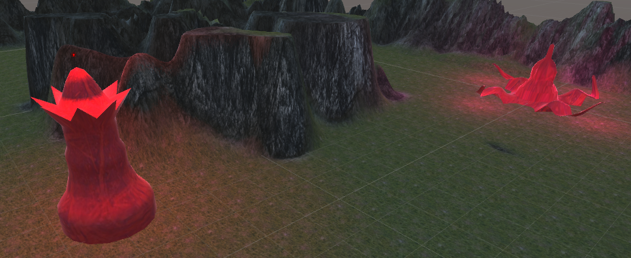

<From prototype>

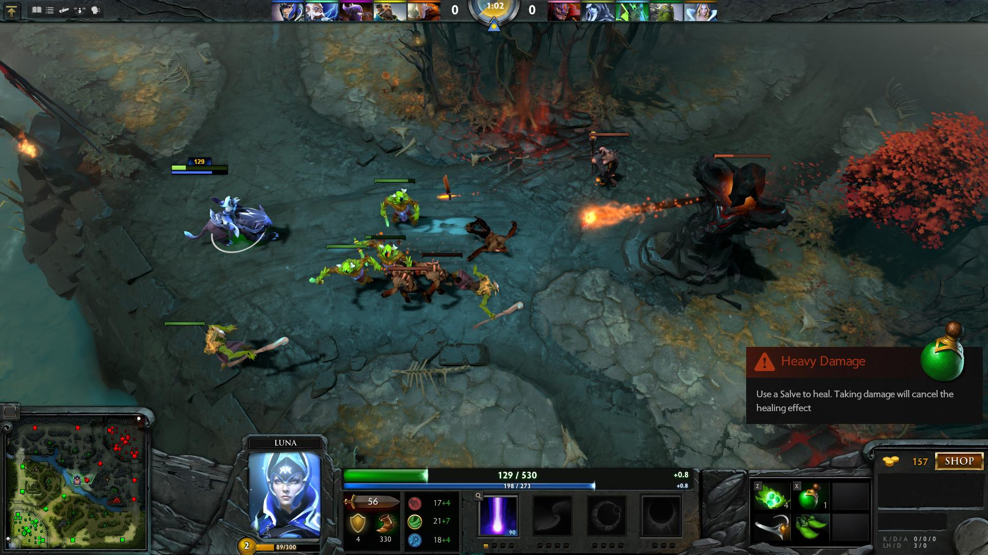

<Similar concept from Dota2>

## 

## 

## Style of Music:

Since the game is about getting into a war, the music used will be sublime like what you would expect in a scene of war.

Ex) <https://www.youtube.com/watch?v=QcfIroNI3NU&list=PLZ6AiehBi0hzXo3CRI3SkJ4NoTcL93tbB>

## Style of Audio Effects:

The audio effects will be what the player would expect to hear in a combat.

[http://soundideas.sourceaudio.com/#!details?id=11517254](http://soundideas.sourceaudio.com/" \l "!details?id=11517254)

[http://soundideas.sourceaudio.com/#!details?id=7560789](http://soundideas.sourceaudio.com/" \l "!details?id=7560789)

[http://soundideas.sourceaudio.com/#!details?id=7600741](http://soundideas.sourceaudio.com/" \l "!details?id=7600741)

# Interactivity

## Controls:

## Keyboard and Mouse:

|  |
| --- |
|  |

Keyboard:

* V : Vantage point view
* P : Perspective view
* Q, W, E, R : Hero abilities(skills)
* ESC : Quit

Mouse:

* Left click : Select minion / character
* Left click on minimap : Moves camera to that location
* Ctrl + Left click : Deselect minion / character
* RIght click : Move the currently selected
* Right click on minimap : Moves all selected minions / hero to that location
* Mouse wheel : Zoom in / Zoom out of map

## Cameras:

Main camera : Top-down view of the map, follows where the player decides, using either mouse scrolling or controls, allows for zooming in and out to see larger map areas

|  |
| --- |
| td.png |

Vantage view : Left shifted ⅔ view for better 3D view of the whole map

|  |
| --- |
|  |

Perspective view : A quick zoom-in of the main camera, also used to show 3D models

|  |
| --- |
|  |

# Mechanics

## Win Condition

Destroy enemy’s home base before the enemy succeeds to destroy ours. There is a 15 minute limit in the game and whomever with more home base HP will win the game. Home base has a certain amount of HP and if it falls to zero, it will be fully destroyed indicating someone has won or lost. Clear message will pop up when losing a game. Screen of text and image would appear to who has won.

## Loss Condition

A player would lose if their home base is completely destroyed or have less HP on their home base than the opponent’s after the 15 minutes are over. Base can be attacked by enemy minions and hero. Home base has a certain amount of HP and if it falls to zero, it will be fully destroyed indicating someone has won or lost. Clear message will pop up when losing a game.

## Combat system

Combat works using either minions or heroes, in the former, the minions are mostly autonomous, with some control given by the player. At all times they will be based on a Rock, scissors, and paper mechanic, with three main types. They will do their own styles of attack which will do bonus damage based on the above mechanic. The minions, while under the player's control will follow his directives, which are given in the form of mouse commands, clicking, and double clicking to choose where to move, and where to attack. Otherwise, the minions will follow an AI state which will always try to get them closer to their main goal, the enemy portal, they will go down a specific path, based on where they are chosen to spawn, and if they run into resistance, whether it is a tower, or enemy, in the form of hero or minion, they will attack the highest priority target within view range.

|  |
| --- |
| **Minion Priority Table** |
| 1. Enemy Base |
| 2. Enemy Hero |
| 3. Enemy Tower |
| 4. Enemy Minion |

The heroes will be solely controlled using the keys Q, W, E, R for ability skills and right clicking to move and attack.

## Leveling system

While the character is in a match, they will gain gold over time per wave, this gold can be used to upgrade their own abilities using the shop, allowing for stronger attacks, more health or other options.

## Turn system

The game is a real time strategy, meaning all players will go at the same time, without a specific turn order. During the game the player will keep track of their minions, making decisions for spawning, and some decisions for where they should move or attack, while also using their hero to get an advantage on the battle arena.

## Resource Management

The game uses Gold as a resource, and it is given over time to the player, there are many different options, you can buy more minions to be spawned in the next wave, upgrade the heroes abilities, or even use gold to recover from an untimely death.

Each team will start with 10 gold. Waves will be produced every minute and receive gold for every start of each wave.

|  |  |
| --- | --- |
| First 5 minutes | 15 gold income per wave |
| Next 5 minutes | 20 gold income per wave |
| Last 5 minutes | 25 gold income per wave |

|  |  |
| --- | --- |
| Tier 1 minions | 3 gold |
| Tier 2 minions | 5 gold |
| Tier 3 minions | 7 gold |

|  |  |
| --- | --- |
| Upgrade hero ability | 7 gold per upgrade |
| Instant hero respawn | 10 gold per use |

# Content – Characters/Units

## Hero

#### Brief Description:

The primary character in the game, the hero that the player controls

#### Visual Description:

The player character will be dependent on which character they choose to do.

|  |  |  |
| --- | --- | --- |
| Image result for dota characters | Image result for dota characters | Image result for lol characters |

## 

## AI characters:

### Sentinel (Tower)

#### Brief Description:

A standing and unmoving statue that passively deals damage to any enemy within range.

#### Visual Description:

Tall statue

#### Gameplay Attributes/Abilities:

Stationary, attackable, destroyable, attacks enemies within specific range using a projectile, or a “cleave” melee arch.

#### AI plan:

Stationary with a cooldown based on enemies.

### Striker Minion

#### Brief Description:

Small minion character, which focuses on high damage melee attacks

#### Visual Description:

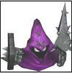

#### Gameplay Attributes/Abilities:

It has medium-level hp with medium melee attack.

#### AI plan:

Moves toward the enemy’s base with the selected path when purchased. It can be controlled by the player. It will attack enemy’s object when approached.

### Tank Minion

#### Brief Description:

Small minion character which focuses on taking damage

#### Visual Description:

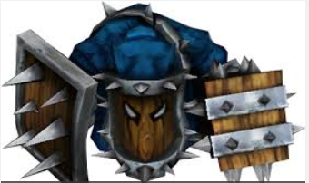

#### Gameplay Attributes/Abilities:

It has high-level hp with low attacking stat. It can only melee attack.

#### AI plan:

#### Moves toward the enemy’s base with the selected path when purchased. It can be controlled by the player. It will attack enemy’s object when approached.

### Caster Minion

#### Brief Description:

Small minion character with ranged attack

#### Visual Description:

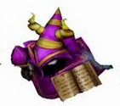

#### Gameplay Attributes/Abilities:

It has low hp but can attack strong with most attacking point amongst the minions.

#### AI plan:

#### Moves toward the enemy’s base with the selected path when purchased. It can be controlled by the player. It will attack enemy’s object when approached.

# 

# Content – Items/objects

## Interactive/World items

### Portals

#### Brief Description:

The world will have two portals, these are the players bases, their end of game health, and most of all their escape.

#### Visual Description:

On screen the players will see a portal, either the color of their team, or of the other team, with a swirling vortex design.

|  |  |
| --- | --- |
| Screenshot (13).png  Not Finalized | Screenshot (12).png  Not Finalized |

#### Gameplay Attributes/Affects:

The items are impassable terrain, that are attackable, as they are attacked, their health will decrease, and if their health reaches 0, the game is over.

### Sentinel

#### Brief Description:

There will be two Sentinel objects in the game, they are statue like towers, that will have two attacks for any enemy that gets within range, the first, is a constant ranged shot, that deals small amounts of damage, and the other being a close range “cleave” that will deal high damage with a very long cooldown.

#### Visual Description:

On screen the players will see a statue standing tall protecting their base, current design does not fit expected plans.

|  |  |
| --- | --- |
| Screenshot (14).png  Tower sensing enemy within range | Screenshot (15).png  Design not finalized |

#### Gameplay Attributes/Affects:

The items are impassable terrain, that are attackable, as they are attacked, their health will decrease, and if their health reaches 0, the object is destroyed. The object can also attack objects which are not on its team.

# Game Progress - World

### World Name: The Northcrown Mountains

#### Brief Description:

The world is a battle arena being held in a mountain like valley location, the game takes place within three lanes with cliffsides on either end of the player.

|  |  |
| --- | --- |
| Screenshot (7).png | Screenshot (6).png |

#### Visual Design:

The environment is more dark, as if the battle takes place in twilight, with grass, hills, and mountains. The arena will have two towers, and two portals, marking the team's bases.

|  |  |
| --- | --- |
| Screenshot (11).png | Screenshot (10).png |

#### Unique aspects:

The game will have the one ‘Level’ which signifies the battle arena.

|  |
| --- |
| 20160307_124239.jpg |